# **Forgotten Password Reset Instructions**

**Step 1:** Go to the Data & Analytics website at <https://www.oha.com/data-and-analytics>.

**Step 2:** Click on the “Log In” link at the top right of the web page.



**Step 3:** On the login page, click the “Forgot password?” link below the Sign In button.

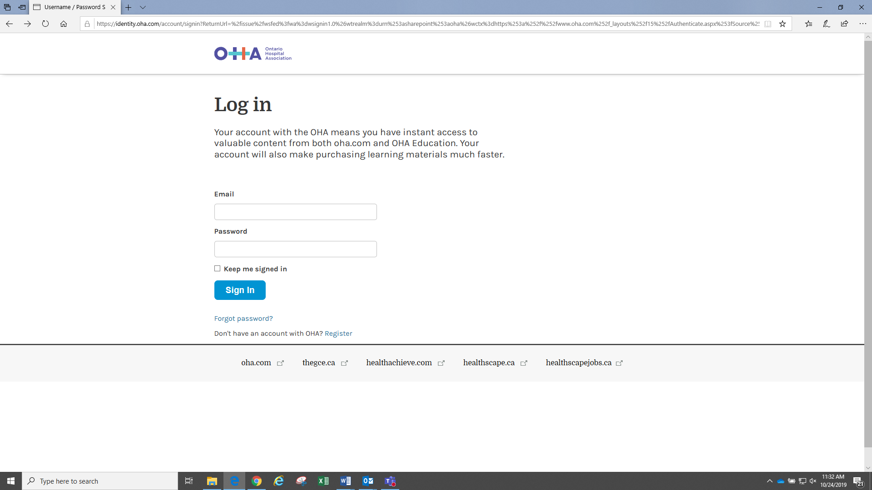

**Step 4:** On the “Forgot your password?” page, enter your email address to request a new password. A new password will be emailed to you.

